**Practical No.2**

Aim: To find the probability distribution of the random variables.

Name: Neeraj Sanjay Shah

Roll no: 51

Class: F.Y. Data Science

Sub: Probability & Distribution

Sign:

**Q1. Let two dice be thrown and the random variable X be the sum of numbers on the upper face of dice. Find the probability distribution of a random variable.**



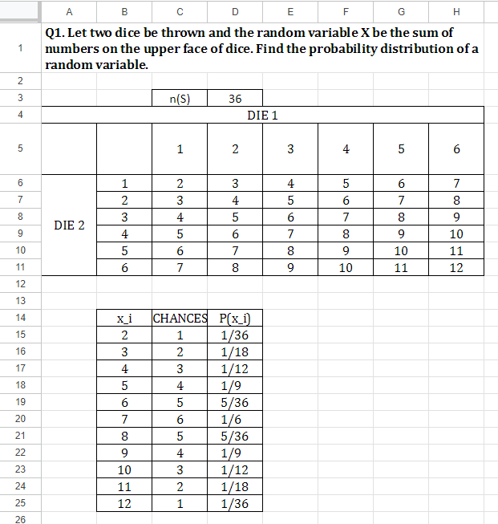

**Q.2 Let 3 coins are tossed, let the random variable X be number of heads obtained. Find the probability distribution of random variable.**

